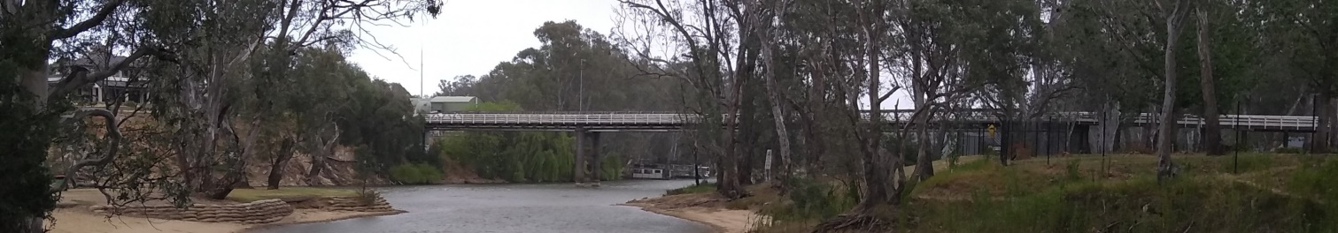

It’s Canberra Sunday Bike Hash’s turn to bring bring you the
Combined Hash Annual Winery Bike Tour
March 20–22, 2020
Location: Corowa , NSW
http://www.murrayriver.com.au/corowa/

Corowa is on the northern bank of the Murray River, the border between New South Wales and Victoria, opposite the Victorian town of Wahgunyah. It is historically important in the development of Australian federation. There are numerous wineries just across the river on the Victorian side (don’t forget to bring your passport and funds for the customs office in Wahgunyah).
There is plentiful accommodation on the river side of the town and more further away from the river – see the attached list

Registration $90
Covers Saturday wine tastings, lunch, G&T stop, circle with a bountiful bucket, dinner and some wine on the tables (then pay as you go); Sunday breakfast.
(Use accompanying registration form to email)
- As in the past, those who want to come along but not ride are able to organise a bus amongst themselves. Let us know if you would like this and we will put you in touch with any others who might be interested.
- A detailed program (including the details of the pub for the Friday evening meetup) will be available after the final recce.
Contact: JR – 0439 886 598 – jr@therossers.id.au

Suggested Accommodation – call them direct for possibly a better deal.

Accommodation on the river side of Corowa
Ball Park Caravan Park – On the bank of the Murray River. Very picturesque park which offers powered and unpowered sites and a range of units. Breakfast on Sunday morning will be here.
Tel: (02) 6033 1426
Bridge Road Corowa
Best Western Heritage Motor Inn
Tel: (02) 6033 1800
25 Edward Street Corowa
Statesman Motor Inn
Tel: (02) 6033 2411
2 Edward St, Corowa
Motel Meneres
Tel: (02) 6033 1066
146 Federation Ave, Corowa
Motel Wingrove
Tel: (02) 6033 2055
147 Federation Ave, Corowa
There is other accommodation further out of town (including Wahgunyah), including motels, two additional caravan parks and a range of holiday accommodation available through Airbnb and other holiday booking sites.
